Homework 5
- Design an EER schema for a database application that you are interested in. Specify all constraints that should hold on the database. Make sure that the schema has at least five entity types, four relationship types, a weak entity type, a superclass/subclass relationship, a category, and an n-ary (n > 2) relationship type. Map the complete EER schema into a relational schema into a set of relations. Specify all primary keys and foreign keys.
Provide required documentation for the previous exercise database. Consult the textbook and Internet such as (https://techwriter.me/best-practices-guide/documenting-databases.aspx). (70 Marks)
- It is important to note that though some attributes are labelled the same, they do not fall in the same domain. Therefore, foreign keys cannot be drawn just based on the literal diagram, but also with a semantic meaning of the values it holds.
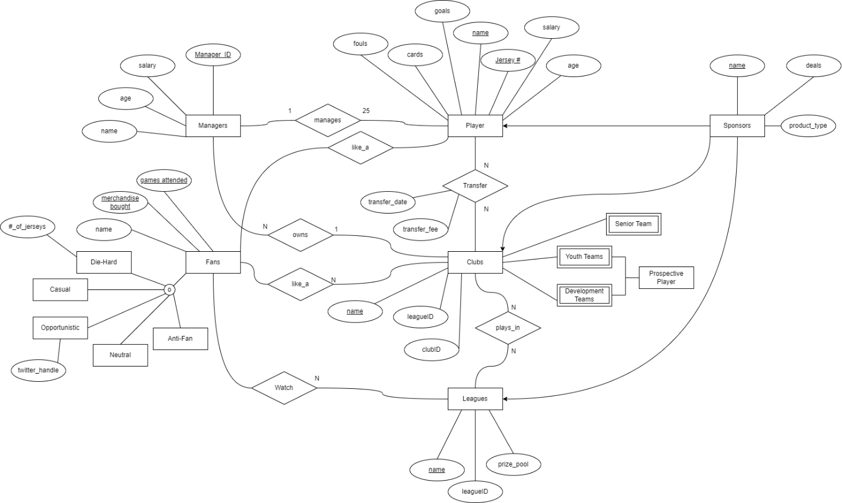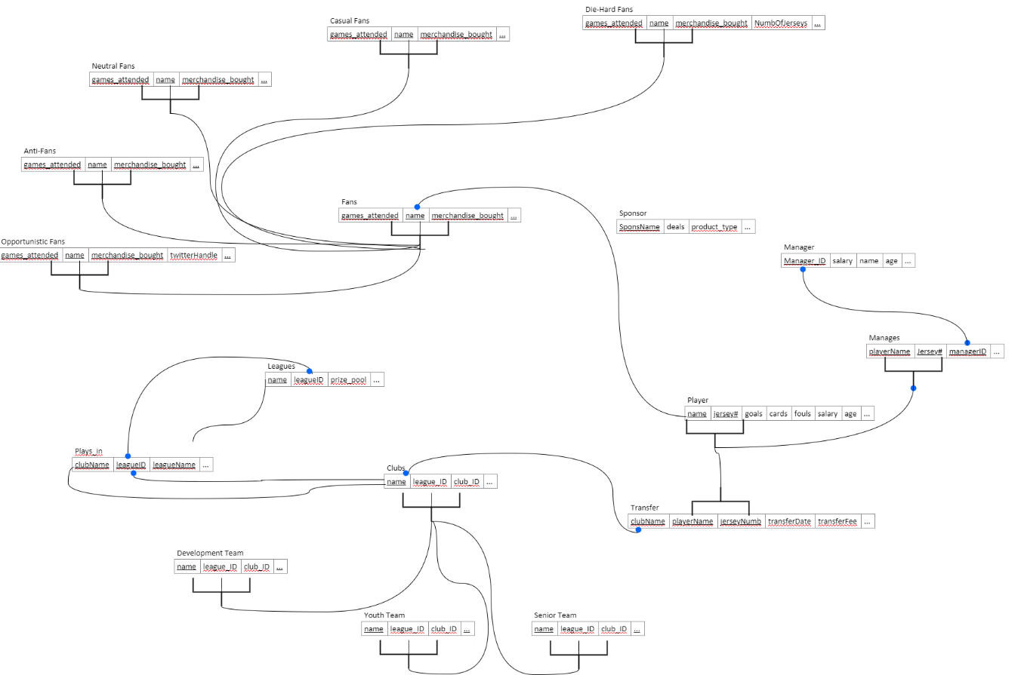
- These will be attached on blackboard.

- Describe user-defined and attribute-defined specializations, and identify the differences between the two. (10 Marks)
- User Defined Specializations: This is typically based on the user’s view and how the user interprets the entities. This is more free of any specific defining characteristics.
- Attribute Defined Specializations: This is based on strict guidelines on a certain characteristic. If it has, does not have, or has a certain type of the characteristic, the entity is then classified accordingly.
- A difference is primarily on how one is based on the view seen by the view whereas the other is a strict guideline.
- A secondary difference is that user-defined must be manually chosen and assessed, whereas attribute-defined can follow a automatic categorization system.

- How does a category differ from a regular shared subclass? What is a category used for? Illustrate your answer with examples. (10 Marks)
- A category (or union) is where two or more super-classes can have the same subclasses.
- A shared subclass has only one super-class.
- A category is used for scenarios where a subclass can be generalized into various entities.
- Taking an example from the diagram, we can look at the entity “Prospective_Players”
- 
- There could be other subclasses that could be derived from either of the entities “Youth teams” and “Development Teams”, but the subclass “Prospective Player” is a category. This is because a “Prospective Player” can be taken from the youth division or from the developmental teams.

- Describe the similarities and differences between an ontology and a database schema. (10 Marks)
- Both are diagrams that have entities and relationships. They are both used to describe systems that must be understood by humans in the conceptual level.
- An ontology is meant to clarify/specify meaning in these systems. These are very broad, pertaining to “human communication, interoperability, search, and software engineering”.
- Database schemas are meant specifically to describe data. These schemas are conceptual and are meant to be directly implemented in database systems. The main purpose is for structuring the data.
- Source: http://www.dl.edi-info.ir/Ontology%20and%20database%20schema,%20What%20is%20the%20difference.pdf

